**CLAP TO CHANGE!**

**What is clap to change?**

Have you ever experienced about this? Presentation with your pointer, You can't fully show your gestures. Or it could be a presentation in front of the classroom with someone standing in front of the computer and pressing the slide. For the projects that our group has created to make presentations more comfortable. In your hand, you don't have to hold any device. Just by clapping at the rhythm or pattern, your work slides will go all out.

**How does the clap detection/Recognition work?**

It’s work by the calculation of the amplitude of the wave. When we clapped the amplitude goes higher. Likewise, when we are quiet, the graph or wave will look plummeting.

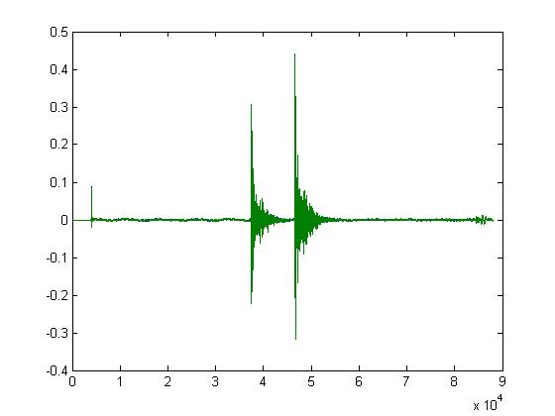

From this figure show about the wave / graph that plotted by *Matplotlib*. In this figure have 2 peaks / periods



**Peak**

**RMS**

As you can see from this figure. The peak point is the highest point of the wave or its amplitude, tribute to the RMS or root mean square value from the mean wave processing over the period. In which our group will use a 2 second interval for the sound waves when clapping our hands to process a full wave (one wave). By calculating the root mean square value can be calculated from.

$$V_{rms}= \frac{1}{\sqrt{2}}× V_{peak} \sqrt{\frac{\sum_{i=1}^{n}{x^{2}}}{N}}=RMS$$

We use the mean square root value for examining the mean amplitude levels over the time period we specified. We will know the noise or standard ambient sound level because the root mean square is the average wave conductivity to find the average amplitude level.

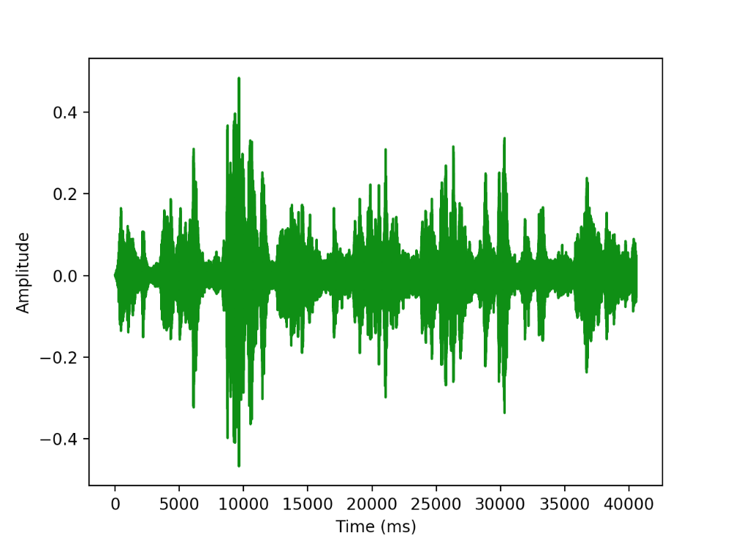

**NORMAL WAVE**



**RMS LEVEL**

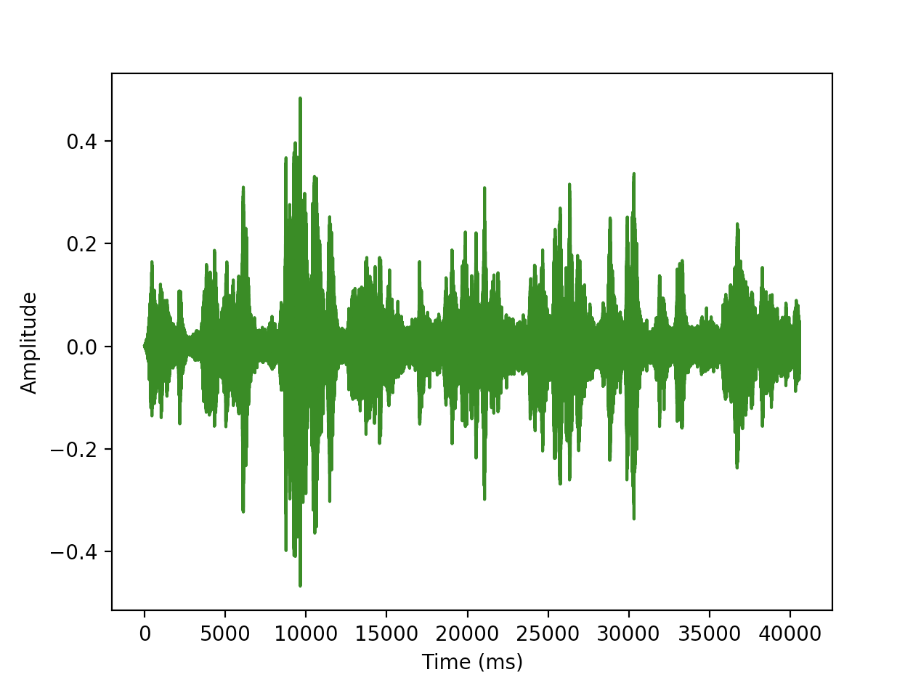

**RMS**

**HIGHER THAN RMS**

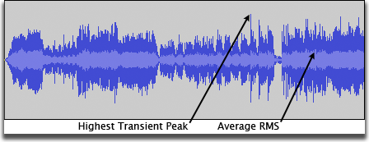

From 1st figure show about The range of amplitude above the range of the root mean square and the portion above from the root mean square.

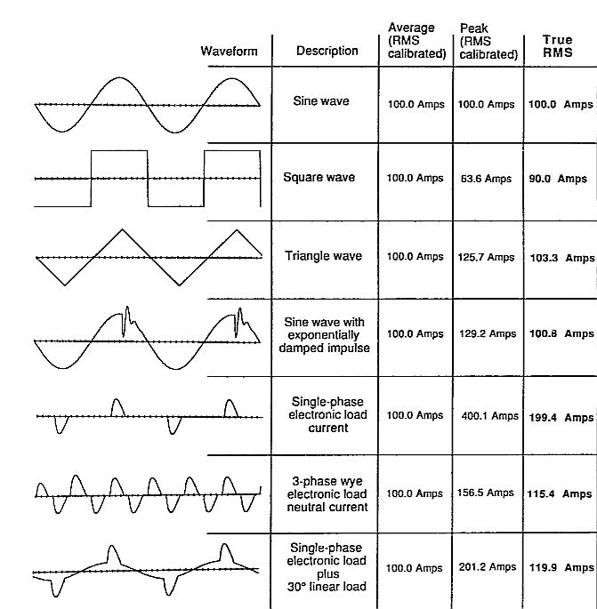From 2nd figure show about Plotting audio across amplitudes in Audacity with mean square root specified in the wavelength.

From the picture above it is a waveform picture. At the top is a sine wave and the bottom image is a picture of a rectangular graph with different areas under the curve.

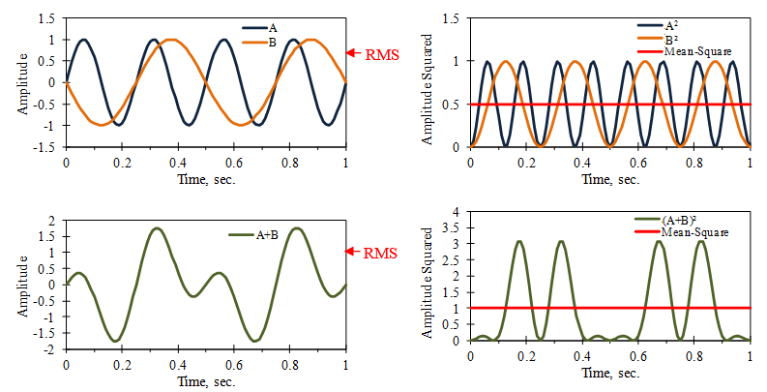

In mathematical calculations, other than the root mean square, there are other values ​​that we can use to find the position of a point on a graph: Vpeak, Vmean, Vmed, Vavg.

It was tested to find the most accurate point on the graph by using the formula above to calculate the value as a threshold, looking at the amplitude that our claps were loud enough to process the clap. Or not If our clap sound is not loud or our sound threshold is not reached. The computer will not process that sound as a clap.

Our test is to use code that is adapted from the original code and converts it from listening to the sound in our microphone to reading the value from the sound. Or is it reading a .wav audio file and processing it as clap or no clap.

We recorded for 20 seconds, counted 12 claps, from less loudness (greater amplitude) to low volume (low amplitude). Counted using Vrms 11 times, Direct Vpeak counted 11 times, Vmean counted 10 times, Vmed counted 11 times and Vaverage count 11 times.

Note that the results obtained in the test were almost no different. Therefore, our group chose to use Root Mean Square as the primary means of wave detection or clapping sensing.

**Now that the clap is counted, how do we control things?**

When our loop is able to receive a clap sound and it can show that the user is clapping. We will continue to expand with a module named Pyautogui, which can be used to control the screen or the GUI of the computer, be it a mouse, keyboard or many other things.

The principle of the program is when the applause. Or applause to True. Use Pyautogui to transpose slides by pressing the Right Arrow key to advance to the next slide and Left Arrow to go back to the previous slide.



CONTROL

